Mus 431 – Assignment #2: Musical Hiccuping

Rhys Batstone V00187492 & Tyler Schmit V00940532
February 28th, 2022.

We acknowledge with respect the Songhees, Esquimalt, and WSÁNEĆ peoples of the Lkwungen language group, on whose traditional, unceded and unsurrendered territory the University stands. These communities and individuals have stewarded the land for thousands of years and their historical relationships with the land continue to this day.
Lesson Plan

- Basic Information
11:35am-12:45pm; Monday, February 28th, 2022; 75 minutes long; high school level (gr. 11 and 12).

- Objectives

- Students will be able to describe musical hiccuping as a musical concept: (through our test).
- Students will be able to identify three different orally-transmitted music traditions which use hiccuping (through our test).
- Students will be able to demonstrate musical hiccuping through performance: (through our musicking activities in class).
- Students will be able to identify four different musical hiccuping traditions: (through our test).
- Students will be able to show how musical hiccuping can abstractify music.
- Students will be able to identify at least one art movement that musical hiccuping is related to: (through our test).
- Students will be able to describe the problems with using the term, ‘hocketing’ to describe musical hiccuping in different cultures; (through our test).
- Students will be able to identify two contemporary musical styles that incorporate musical hiccuping: (through our test).
- Students will show versatility in musical hiccuping by trying it in different modalities and styles: (through our musicking activities in class).
- Students will be able to give an example of how hiccuping is used in modern music.
- Students will be able to recognize and identify musical hiccuping in music outside of the classroom environment: (post-lesson experience).

- FNPL
- Learning is holistic, reflexive, reflective, experiential and relational (focused on connectedness, on reciprocal relationships, and a sense of place).
- Musical Hiccuping requires that participating individuals have to relate and connect with others on a focused and concentrated level in order to coordinate their shared roles and responsibilities to make the technique work. A sense of place is established as individuals come to understand that they are one small part of a whole, and only with the whole working together in synchronicity is achieved. Furthermore, egalitarianism and conversational attentiveness are fostered in this process.
- Learning involves the role of indigenous knowledge.
- This principle will be addressed by directly teaching about indigenous musical traditions from other cultures. To emphasize that their musical traditions are older and are at least as valuable as Eurocentric musical knowledge, we have chosen to not use the term, Hocket, and instead are calling the concept Musical Hiccuping.

- Pre-requisites
- Students will have prior experience with performing in a musical ensemble
- Students will have prior experience with learning melodies through call-and-response/oral transmission
- Students will have prior experience with the basics of ear training and music theory (pre-post secondary 1st year level).
- Environment
- Projector screen will be needed for showing audio and video materials on hocketing.
- Students will be seated in a semi-circle formation while we teach from the projector.
- (See *Example I)
- Students will be seated in a circle for our first two musicking ideas
- (See *Example II)
- Students will be situated in three standing circles for our final musicking activity.
- (See *Example III)
- (Diagrams provided below)
- Materials/Technology/Instruments
Classroom computer
Projector screen
Cell phone for recording
Bluetooth speaker
- Equipment
Same list as point 6.

- Anticipatory Set Introduction Pre-Test
- “On a scale of one to ten, can everybody show us on their fingers how their reading break was?”
- After Territorial Acknowledgment, we will begin our introduction to the class in a ‘hiccuping’ style.
- Sequence 1
- Lecture: Highlighting Indigenous music and musicians.
- Lecture: Introduction to the term Musical Hiccuping
- Interactive Musicking Activity (spoken and pitched): Trying out simple Hiccuping with the class
- Lecture and Listening Activity: Musical Illusions - how musical hiccuping can abstractify music
- Lecture: Musical Hiccuping will be related to two important art movements, to show a relativistic quality to the practice, and to relate it to things outside of music
- Lecture and Musical Example: Medieval French Hocketing, its historical significance as first notated hiccuping tradition, and showing how it sounds
- Lecture: Discussing the sociological problems with using the term “Hocketing.”
- Interactive Musicking Activity 2: Pitched singing and Hiccuping of a well-known pop tune. “Dynamite” by Taio Cruz
- Lecture: Hiccuping traditions from African cultures will be explained with anthropologic consideration
- Musical Examples: Giving examples of hiccuping from the Baka and the Ba-Benzele people’s musical traditions
- Lecture and Musical Example: Giving the class information on the Indonesian tradition of hiccuping in music - namely, Gamelan music. Identifying two main instruments and features of hiccuping in Gamelan. Showing a musical example of Gamelan hiccuping on metallophone. Teach how Gamelan is an orally-transmitted musical tradition.
- Lecture: Inuit Throat singing. Discuss how dates are unclear for age of the practice. Identify a few of the Indigenous names for throat singing. Discuss how the practice is traditionally done and its role in Inuit society. Discuss how throat singing was nearly wiped out by interference by the church. Discuss how throat singing is alive and well, and currently thriving with renewed interest in Canada. Mention Tanya Tagaq and why she is an important artist.
- Musical Example: Give an example of Inuit throat-singing through a video, which also explains much of the cultural practice.
- Lecture and Musical Examples: Discussing the many realms of contemporary music in which hiccuping is found. Discussing how the loop pedal and other technologies have allowed for more solo hiccuping. Discuss how more experimentation in solo hiccuping is happening for instrumental/singing composition. Showing musical examples that demonstrate the different styles in discussion.
- Interactive Musicking Activity: Showing how to construct a hiccuping device that has interlocking and interactive parts on three separate levels. Showing how this can be applied to popular music. Showing how even more complex musical hiccuping can be taught and learned through oral transmission.
- Discussion: Concluding our assignment by asking for feedback and questions from students, as well as giving some leading questions to help students draw their own conclusions regarding the holistic benefits and opportunities that musical hiccuping represent.

- Sequence 2
- Shown by talking about Reclaimed on CBC, which is all Indigenous contemporary music.
- Demonstrating it orally through our “hocketed narration.” Describing the technique itself.
- Getting into a circle and doing our first musicking activity: One Word Story. We’ll do two iterations of this activity: one with just spoken words and one with sung words.
i) Explaining the activity
ii) Trying the activity with spoken words
iii) Trying the activity with pitched, sung words.
- (A) A list of hiccuping characteristics that contribute to abstractifying music will be given. (B) An example of a musical illusion will be played for the class with accompanying talking points, including questioning the class about what they heard. (C) The musical illusion will be explained.
- (A) The class will be asked to think of an art movement that relates to Musical Hiccuping. (B) When chosen a student will identify an art movement and explain how it is related to M.H. If no one is able to think of an appropriate art movement, we will move on to point (C) Accompanying the information appearing on the slide, we’ll talk about how Pointillism and Cubism are similar and related to M.H.
- This concept will be taught through (A) talking about it in our script, and (B) showing a clip of French Hocketing.
- This will be done by (A) talking about it in our script and (B) accompanying text in slides to reinforce.
- To be taught by call-and-response aural recall. (A) Teacher sings the first phrase of melody and signals for class to sing it back. (B) Teacher sings the second phrase and signals for class to sing it back. (C) Teacher sings the third and fourth phrase in the same fashion. (D) The class will sing the entire song sentence together. (E) The class will be given instructions on how to turn the song into a Hiccup, by each student contributing only one syllable of sung material around the circle. (F) point E will be repeated, but with the new instruction for students to sing the song word by word instead of syllable by syllable.
- (A) We will first identify the main cultural groups that use Hiccuping by name and territory. (B) Give information on the estimated timeline of hiccuping in Africa, and its evolution through history. (C) Explain why it is believed that these traditions developed independently of one another. (D) Identify some of the instruments used in African instrumental hiccuping.
- (A) Show musical example one, noting the individually-hiccuping yodeller and the group-based hiccuping. (B) Show musical example two as an example of rhythmic hocketing, and note that it comes from the same females from the same peoples, the Baka. Reinforce the idea that fun is a repeating element in musical hiccuping. (C) Show musical example three and note that the Hindewhu style is distinct from the Baka style of hiccuping. Teach that Hindewhu involves a mixture of instrumental flute and vocal sounds. Reinforce the idea of polyrhythm as a kind of hiccuping.
- The Indonesian Gamelan tradition will be explained through lecturing and slide notes as will the identification of two main instruments and features of hiccuping in Gamelan. A musical example will be played of Gamelan hiccuping on metallophone. Gamelan’s orally transmitted nature will be discussed through our lecture and slide notes.
- (A) Information regarding the age, practices and terminology of Inuit throat singing will be addressed in our lecture and slide notes. (B) The historical and social impact of the Catholic church banning throat singing will also be discussed in our lecture with aid of the slide notes. (C) Finally, highlighting the modern resurgence of Inuit throat singing and Tanya Tagaq will be addressed through our lecture and slide notes.
- The accompanying video will also reiterate and explain in more depth the cultural practices of Inuit throat singing, as well its technical components, and social significance. It is our hope that all multicultural (including contemporary) musical examples will have the added benefit of creating a strong emotional connection to our topic.
- Discussing the many realms of contemporary music in which hiccuping is found will be done by mixture of lecturing, providing slide notes, and providing musical examples to show how exactly hiccuping is used in those styles. Additional time will be spent to discuss how looping and other technology such as turntablism have used hiccuping to dramatic and prolific effect, and its widespread use in Electronica and Hip-hop. We will also show how looping has made solo hiccuping more accessible by showing a musical example, and teach that this is another technique that has profoundly influenced Electronica and Hip-hop. This information will also be exemplified through musical examples.
- In order to show how to construct a hiccuping device that has interlocking and interactive parts on three separate levels, we start by teaching each level separately. (A) The first level is rhythm. That pattern will be demonstrated and then put into practice by the first circle of people. (B) The second level is the “Ooga-Chakas,” which will be taught in the same way: Demonstrating the pattern to the group, and then having them put it into practice. (C) Once level one and level two are comfortable hiccuping their parts on their own, they will be combined so that they are hiccuping together in their respective patterns. (D) Finally, the last level - singing of the melody - will be taught with aid of the lyrics on the screen. This will be done at a remedial tempo to start. It is likely to take several tries to refine the coordination between people’s sung words. (E) Once level three is comfortable with hiccuping the melody and the speed has been satisfactorily increased, we will have all three groups simultaneously hockey within their levels. (F) The exercise conclude with the last melodic phrase of the introduction: “Aaaaa, aa-aaaa, aa-aaa… Hooked on a Feeling!” Using Hooked on a Feeling by its nature exemplifies how hiccuping can be applied to popular music and taught orally/aurally. (G) For added difficulty (and time permitting), we will try an added bonus level of difficulty: at the end of every four bars, one person from each level will transfer to the next circle, and take up the hiccuping pattern of their new group. This activity is an expansion of the concepts of communal concentration and cooperation that are part of musical hiccuping.
- (A) To conclude our presentation, a brief question period will be held which will serve to give students the opportunity to seek out additional information on the topic that they may be curious about. (B) If there are not many questions, we’ll ask our own questions to the group which are designed to get students thinking about the holistic and socially important concepts that are inherent to hiccuping, and how it is a valuable platform for addressing othering, alternative musical learning and egalitarianism in the music classroom.

- Evaluation Assessment
A written test will be used as our evaluation tool. The test will feature a mix of multiple choice, matching, true/false, and written questions. It is out of 25 points with one bonus question. This test will analyze students' understanding of the article and lesson equally.
- Extension Follow-up
For subsequent lessons, we will incorporate instrumental hiccuping in rhythmic and melodic contexts, and explore a wider variety of material we can alter with hiccuping. Additionally, we will explore even more musical traditions that use hiccuping and find more examples of musical illusions to discuss.
- Time and Sequence: Task Analysis
- (1:00) - Territorial acknowledgment & Extension
- (3:00) - Up to first activity
- (6:00) - End of first activity
- (12:00) - Up to Second activity
- (20:00) - End of Second activity
- (28:00) - Up to 3rd activity
- (30:00) - Set-up/introduction/explanation of activity
- (32:00) - Running the first level’s hiccuping pattern
- (33:00) - Running the second level’s hiccuping pattern
- (35:00) - Running both level 1 and 2 together
- (37:00) - Trying a switch of one person each from level 1 to level 2 while hocketing
- (39:00) - Running level 3’s lyrics in unison, and then hiccuping
- (44:00) - Trying all three levels, hiccuping together
- (47:00) - Trying all three levels hiccuping together with one person switching to a new group every four bars.
- (49:00) - End of 3rd activity
- (50:00) - Conclusion
- (55-75:00) - Test and Reflections
- Script
- Included as a separate document.

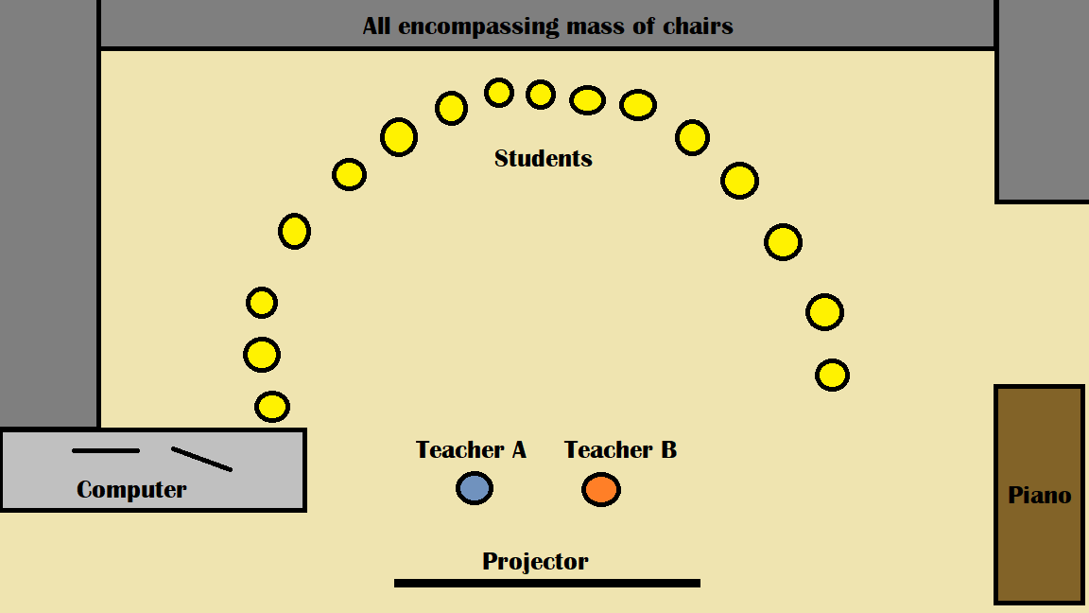
Class Set-up Diagrams

*Example I

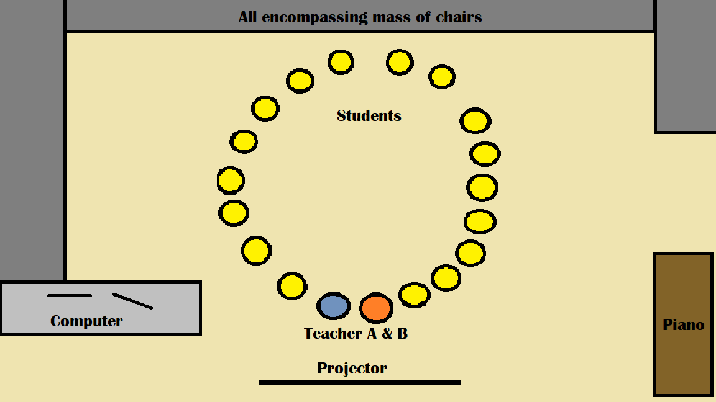

*Example II

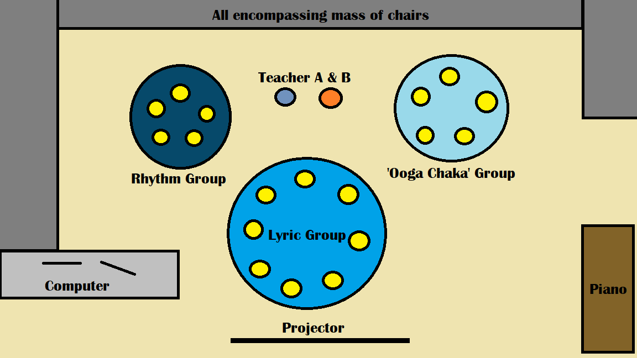

*Example III

Assignment 2 script:

T: “Hey everybody, we’re going to get started. First, we’d like to know how everybody’s reading break was. On a scale of one to ten, can everybody show us with your fingers how you feel it went?”
- Reactionary statement of sympathy or acknowledgment of how people’s reaction is. Something like, “Wow, I’m glad it went so well for most of you,” or “Sorry it wasn’t so great for some of you.”
R: “Before we jump into our topic today, we’d like to acknowledge the territories.”
T: “We acknowledge with respect the Songhees, Esquimalt, and WSÁNEĆ peoples of the Lekwungen language group, on whose traditional, unceded and unsurrendered territory the University stands. These communities and individuals have stewarded the land for thousands of years and their historical relationships with the land continue to this day.”
R: “As music educators, it’s important for us to show our commitment to the process of decolonization and Indigeneity by actively seeking out experience with Indigenous music and musicians. An incredibly easy and enjoyable way in which we can do this is by listening to Reclaimed with Jarret Martineau on CBC Radio (92.1 FM), from 6-7 pm on Wednesdays. Reclaimed is a weekly series on CBC Radio that explores the many worlds of contemporary Indigenous music from traditional songs and acoustic sounds to Native hip-hop, R&B, and the dancefloor-filling beats of electric powwow. Listen on the free CBCListen app at any time.”
(Hi, I'm Tyler and I'm Rhys. Welcome to our lesson on Musical Hiccuping. So what is Musical Hiccuping?)
(1:00) T: “Hi;” “-Tyler.”; “-I’m”;-”-Welcome”; “-our”; “-on”; “-Hiccuping.””-what”;”-Musical”…
R: -”-I’m”; “-and”; “-Rhys”.;-”-to”; “-lesson”; “-Musical”;-”-So”; “-is”; “-Hiccuping?”
T: “It's a term we're using to describe a musical practice that has roots in many different cultures across the world.”
R: “From the Inuit, to many African cultures, to Indonesia, to French liturgical music, to contemporary music like Electronica and Hip-Hop, to many other examples, this technique appears again and again as a way of sharing and performing music together.”
T: “Essentially, the technique involves the sharing of melody and/or rhythm between two or more voices or instruments. A melody is broken into short segments, often one or two notes each. The segments are then assigned to individuals to play or sing.”
R: “The melody is put back together when individuals combine their parts, and the whole melody is heard again. To help us get familiar with the concept, let's try a fun activity. We’ll need everyone to please quickly arrange their seats into a circle around the room.” (2:50)
- - approx. 30 seconds to organize the seating.
T: “This activity is called One Word Story. We will go around the circle, and make up a story together. Each person can only add one word at a time to the story. When we’re doing this, try not to be too clever with your word. The object is to think fast and maintain a flow through the storytelling, as if there was only one narrator. This is going to take focus and coordination to make it run smoothly. Ready? Rhys and I will start:”
T: “Once”
R: “upon”
(The game ensues around the circle. When returning to Tyler:)
T: “The”
R: “end. - Please arrange yourselves quickly into a semi-circle again!”
- Approx. 30 seconds to reorganize the seating.
T: “In many cultures, musical hiccuping is often treated as a kind of game. The technique is highly conversational and interactive by nature. By breaking up and sharing melodic or rhythmic components with others, we practice cooperation, the sharing and coordination of roles and responsibilities, and intensive focusing and listening to one another. Musical hiccuping can dramatically reshape the way music sounds by playing with different timbres and octave ranges. These sonic effects can be used to provide a sense of abstraction or illusion to the music. Here’s an example:”
R: “Can you tell what popular song this is? What about when the notes are all put back into their proper octave range?
This demonstration is a version of Diana Deutsch’s Mysterious Melody illusion. It shows how pitch range is an essential part of melodic perception. Although all of the notes stay in exactly the same pitch class (e.g., a C note remains a C note) the melody is much harder to recognize when the notes are semi-randomly scattered across higher and lower octaves. For many cultures, this is an important aspect of hiccuping. The music is scattered between high and low registers thereby hiding the full melodic or rhythmic context until brought together.
Can anyone think of a movement in visual art that shares ties with Musical Hiccuping?
- Wait for hands and answers (approx 20 seconds)
That’s right! Cubism/Pointillism are related! (or) That’s an interesting idea! I was thinking more along the lines of Cubism or Pointillism.
Pointillism is when small, distinct dots of colour are applied in patterns to create an image.
Cubism is objects are analyzed, broken up and reassembled in an abstracted form—instead of depicting objects from a single viewpoint, the subject is depicted from a multitude of viewpoints to represent the subject in a greater context.”
T: “There are many different words to describe this concept, depending on which culture it comes from. For the Inuit, the word is Kataqjjaq. In the Busoga kingdom in Uganda, it is called Bigwala. Depending on where you are in Indonesia, it can be called Imbal or Kotekan. Arnold Schoenberg described it as Klangfarbenmelodie. And in Medieval France, the term was Hocketing.”
R: “Formal transcriptions of hocketing first appeared in compositions from the Ars Antigua movement in 13th Century France. Composers like Guillaume de Machaut and Perotin used the technique extensively. For many monks who sang this music, hocketing was considered a game. Medieval clerics from the era wrote about how fun it was. It was so much fun apparently that in 1325, Pope John the 22nd banned its use in church. This is an example of what it sounds like:” (play clip)
T: “The term “hocketing” originates from Medieval France. The English translation of the word is “hiccupping.” Although the French were the first to coin the term, examples of this practice date much further back in various cultures as a musical tradition.”
R: “Hocketing is often used as a catchall term to describe a musical practice that has developed independently across many different cultures throughout history, without influence from one another. To use this term in this way promotes the world view that musical practices need to be legitimized through a Eurocentric lens. To try and get away from using the term hocketing, we have chosen to refer to the practice as Hiccuping instead. As we progress through our lesson, try to think of what name you might give it.”
T: “Ok, it’s time to dive into hiccuping some more by trying a new activity. Let’s all stand in a circle around the room. Space yourselves out nicely! - class spaces out -This activity is called Dynamite. We’re going to learn the pop song, “Dynamite” by Taio Cruz. Then we’re going to break up the melody in two slightly different ways to give it a Hiccuping effect. First let’s learn the song.
R: “Ok everybody get ready to listen and sing. - I throw my hands up in the air sometimes” - points to the group to sing it back to us. - “Singin haaaay-yo, Baby let’s go” - points to the group to sing it back - “Cuz it goes on and on and onnnnn” - points to the group to sing it back - “yes it goes on and on and onnnn, yeah.” - points to the group to sing it back. - “Let’s sing the whole thing together now! Ready?” - conducts prep beat, and we sing the whole song through.``
T: So now, we’re going to take it a little slower, and we’re going to sing this syllable by syllable around the circle. Be careful, because some words in the song are more than one syllable! You’ll need to mentally sing along and anticipate what your note will be for this to work fluidly. Are we ready to try? Rhys and I will start.”
R: “I”
T: “throw”
- The rest of the class continues the song. If there are difficulties, we will assist and re-clarify, then try again.
R: “That was awesome! On a scale of one to ten, show me on your fingers how hard that was for you guys? What are some challenges when trying to do musical hiccuping? Let’s try it one more time, but this time instead of one syllable each, we’re going to try one word each. That means some of you will still be singing only one note, and some of you with longer words will be singing more notes! Let’s see if we can keep the flow of the song by listening and anticipating. BY THE WAY: “aaaaa-yo” is considered one word. Ready?”
R: “I”
T: “throw”
- The same process is repeated as for the first iteration of our activity.
R: “Really well done, everybody. On a scale of one to ten, with your fingers, show me how difficult that was. (Makes a reactive statement) Let’s sit back down again.”
T: “As we’ve mentioned, several hiccuping traditions predate the French hoquet tradition. While Medieval hocketing happened roughly 700 to 800 years ago, it is believed that African ‘hiccuping’ traditions date back roughly 80,000 years. There are a number of hiccuping traditions that come from different places in Africa. Research has shown that these traditions have developed largely independent from one another. For example, it’s believed that the Bush People of the Kalahari Desert region never interacted with the Mbenga and Baka peoples of Central and Western Africa. Nevertheless, they each developed their own musical hiccuping practices. “
R: “Four of the main peoples who have prominent hiccuping traditions are as follows: the Mbuti (from the Central and Eastern Pygmies); the Mbenga (aka the Ba-Benzele) and the Baka (from the Central and Western Pygmies); the Batwa and Gogo (from Southern Uganda and Tanzania); and the Basarwa, Saan or Bushmen peoples (from the Kalahari desert region in Southern Africa). The earliest known hiccuping began with the Baka and Basarwa peoples. It began as simply vocal hiccuping as you heard with the Baka women yodellers. Over the course of time though, instrumental hiccuping began to happen with the development of various kinds of flutes, trumpets, idiophones (which are basically xylophones), zithers, and of course drums. Rhythmic hiccuping is a practice that is even more ubiquitous throughout many African musical cultures.”
T: “We’d like to show you three examples of hiccuping from African cultures. The first two come from the Baka people, and the last comes from the Ba-Benzele people. Our first clip is a song called Yelli. It’s sung by women ‘yodellers.’
- Play first clip
Similar to the musical illusion we showed you, melody is abstracted by the alternation between upper and lower registers in each individual voice. This is the yodelling effect that you hear. Then there is a second layer of hiccuping, since the melodic content is broken up and shared in a cascading effect among the singers.
The second clip also is an example of rhythmic hiccuping, and it’s also performed by Baka women. This practice is called Liquindi, or water drumming. Let’s listen.”
- Play second clip
R: “Our third example shows a mix of vocal and instrumental hiccuping. This technique is called Hindewhu, and it comes from the Ba-Benzele people. In this technique pitches are alternated between a flute or reed pipe, and sung pitches. The clip we are showing you is performed by a Ba-Benzele woman on Herbie Hancock’s iconic recording Watermelon Man
- Play third clip
T: “Another culture that is famous for its Musical Hiccuping is found in Indonesia. The Gamelan is the traditional ensemble music of the Javanese, Sudanese and Balinese people of Indonesia. This music is performed on percussive instruments like the metallophone, demonstrated in the video, and the kendang, a two-headed drum that creates the pulse. Two region-specific variations of Gamelan song contain musical hiccupping: Kotekan - originating from Bali, features sophisticated, fast interlocking parts; and Imbal - Javanese for “to repeat”, refers to a rapid alternation of a melodic line between instruments. Gamelan is estimated to be roughly 1800 years old. This practice is orally transmitted. It has traditionally had no notational system, although in the early 1900s one was developed by French Missionaries in an attempt to write down the music for “archival purposes.” Here’s an example of Gamelan music that involves hiccuping. Here’s an example of kotekan music.
- Play clip
R: “Let’s talk about one more culture that has a long-standing musical hiccuping tradition: The Inuit. Inuit throat singing has no certain date of creation, but we can say it has existed as long as the people who practice it. Calculating how long the Inuit may have existed is still pretty unclear, with estimates anywhere between 1,000 and 12,000 years ago. Inuit throat singing has a number of Indigenous words, including Katajjaq, Iirngaaq, and Pirkusirtuk. The practice began as a game between pairs of women who would sing while the men were out hunting. The women commonly hold each other’s arms, focusing on precise breathing patterns and alternation of sound. Often, the women will share the resonant chambers of each other’s mouths to amplify and manipulate the music they create. Western Colonialism has had a historically devastating effect on Inuit cultural practices, including throat singing. Throat singing was seen as satanic and banned by the Catholic church, nearly destroyed with many other Inuit practices. The ban was not lifted until the 1980’s, and has managed to survive and even thrive today. Who in the class has heard of Tanya Tagaq before? - waits for hands; if there are, allow one to talk about her. If no hands… - Tanya Tagaq is an Inuk throat singer who has won numerous awards for her music. She’s responsible for bringing awareness and resurgence to the art of Inuit throat singing. She’s collaborated with many contemporary artists as well, including the Kronos Quartet, Buffy Sainte-Marie and the rock band July Talk.”
T: Finally, we’d like to talk about Contemporary examples of Musical Hiccuping. There is so much to say about hiccuping in contemporary musical styles. It’s a technique that has found its way into Rock, Indie, Hip-Hop and Electronica all without us noticing! An early 20th century name some of us may know, Anton Webern, experimented with this concept. We had a jazz example earlier in the lesson by Herbie Hancock using a flute hiccup, and we have another great one from the trombones in Duke Ellington’s “Braggin’ in Brass, check it out.” Hiccuping is used frequently in jazz composition.
- Play clip
R: Wow! Notice how the hiccuping in that example really creates a cascading effect amongst the trombonists. Next we travel to the 90’s for some classic Hip-Hop. Run-DMC’s iconic song It’s Tricky features an intro with traded words between the two artists. Plenty of examples of hiccuping wordplay are found throughout their discography, and in the genre of the time. Hip-hop was not only shaped by vocal hiccuping, but also instrumental hiccuping. The art of turntablism involves cutting up and mixing sonic material from two records being played at the same time. A mixer is used to alternate between the two records, creating a hiccup effect. The records themselves are also manipulated by hand to add to this back-and-forth interplay between the records. When sound materials are mixed in this hiccuping style, a new sonic landscape and completely new, fresh piece of Hip-hop music is created. Turntablism has had a profound effect on the Hip-hop tradition.
- Play clip
T: Staying in the 90’s, one composer has taken a specified approach to this technique in her pieces. Meredith Monk is a late 20th-century composer whose pieces feature aspects of hiccuping to create tension and give an uneasy sense to the music. A quote from Monk herself describes the feeling of “being on a tightrope with no clothes on” and “not being sure if you’ll make it through”. Her music exemplifies the egalitarian nature of musical hiccuping, and shows that it requires all performers to be locked in and focused - working together towards the common purpose of creating musical singularity and coherence. Here is a haunting clip of one of her pieces.
- Play clip
Another example of her music shows how musical hiccuping can be done with only one person.
- Play clip
This technique of alternating between playing the saxophone and singing pitches is similar to the Hindewhu technique that we heard in Watermelon Man.
R: Solo musical hiccuping is a growing trend thanks to several technologies that are now used a lot in contemporary music. Aside from turntables, another important tool is the loop pedal. This allows artists to record one part of a hiccup, loop it, and then record the other part. Extremely complex layering and overlapping of sounds can be done using a loop pedal. Marc Ribillet of Youtube fame is a great example of a looping specialist, as is tUNE-yARDS. Let’s listen to how tUNE-yARDS uses looping to create hiccuping in her music. This is her piece, Bizzness.
T: Next, we have quite a recent example that some may be familiar with, Bangarang by Skrillex. This is another great example of hiccuping in popular music that I’m sure many people have noticed but never had a name for. Listen to how the synth and the voice have a similar timbre, drastically leaping around the melodic line. By programming a large number of samples into a quickly-changing patchwork like this, Skrillex is showing how musical hiccuping is a huge part of EDM. The practice holds many similarities to that of Turntablism. Many different subgenres of EDM use this technique all the time. Another important factor is that technology like turntables and production software allow musicians to hiccup as individuals without the need for other performers.
- Play clip
R: Our final example shows how EDM effects can be arranged for acoustic groups such as a choir by using hiccuping. In The Pentatonics’ rendition of Daft Punk’s Harder, Better, Faster, Stronger, a decidedly electronic effect is maintained by the group’s hiccuping of the melody.
- Play clip
T: Now that everyone has an understanding of musical hiccuping across so many eras and genres, let’s do an activity featuring a song I am sure many of us will know! For our final activity, we will demonstrate musical hiccuping as an ensemble to the tune of Hooked on a Feeling by Blue Swede. I’m going to create three groups right now. Once you have your group, please stand in a circle! Number people into two groups of 5 and one group of 8. Could I please have the group of 8 standing in the middle of the classroom? Then could I please have one group of 5 stand on the left side of the classroom and the other group of 5 on the right.
- Wait for class to organise into respective groups and positions (approx. 30s)
- Commence Activity #3
R: Thank you so much everyone for participating in our activities and being such amazing listeners for the slideshow! Did everyone have fun today? Cheers of joy and grandiose laughter That is great to hear! Next class I’ll ask that everyone please bring their instruments and we will try some instrumental hiccuping with each other. Can everyone find their seats again please!
T: To close our presentation, we want to make sure you have time to ask any questions that you might have about musical hiccuping. So now is the time! Please let us know if you have any, or if you just have a comment that’s ok too.
R: Since there are no (more) questions, we have some questions to pose to you.
- Has anyone tried anything like this hiccuping technique before? Tell us about your experiences.
- What makes musical hiccuping unique and distinct?
- What does it take to do good hiccuping in an ensemble?
- How is plurality made into singularity when we hiccup together?
- How is Musical Hiccuping related to othering?
- The First Nations Principles of Learning that we focused on today are: a) Learning is holistic, reflexive, reflective, experiential and relational (focused on connectedness, on reciprocal relationships, and a sense of place). And b) Learning involves the role of indigenous knowledge. How do you think those principles are related to Musical Hiccuping?
Thanks everyone for this discussion! I hope you all learned something interesting today, and we look forward to learning with you again soon.”
~Fin

Musical Hiccuping Test
- Match the hiccuping technique to the style (/2)
Indonesian Throat singing
Inuit Hoqueting
African Loop pedals
French Liquindi
Contemporary Gamelan
- Circle the hiccuping tradition that is not orally transmitted historically (/1)
Hocketing Gamelan Hindewhu Katajjaq
- Why was hocketing banned by the Pope in 1325?
- It wasn’t being done in Latin
- Women were doing it
- It was considered Satanic worship
- It was considered to be too much fun
- Circle answer: African hiccuping traditions are estimated to be 80,000 years old (/1)
True / False
- Circle the composer from Medieval France who used hoquets (/1)
Hildegard von Bingen Monteverdi Machaut Palestrina
- What led to legitimizing the term Hocketing as a term for other people’s musical practices? (/1)
- It was easier to say than other people’s terms
- The French invented the technique first
- Exhaustive institutional documentation in Latin
- French language has roots in several African regions
- A 20th Century composer who used hiccuping in their work was… (/1)
- Leonard Bernstein
- Anton Webern
- Olivier Messaien
- Ralph Vaughn Williams
- William Grant Still
- A contemporary composer who actively features hiccuping is… (/1)
- Nils Frahm
- Snoop Dogg
- Ben Folds
- Meredith Monk
- Maria Schneider
- Circle 2 art movements related to hiccuping (/2)
- Pointillism
- Cubism
- Expressionism
- Realism
- Impressionism
- 2 contemporary musical styles that use hiccuping are… (/2)
- Country
- Electronic
- K-Pop
- Hip-Hop
- R&B

- Circle answer: The Dirty Projectors are not a band that experiment with Hocketing (/1)
True / False
- Describe two technologies that have allowed people to do hiccuping without the help of other performers:

- Circle one modern EDM artist who is well known for using hiccuping (/1)
- Disclosure
- Kaytranada
- Calvin Harris
- Skrillex
- Circle answer: Gamelan primarily uses sung pitches, not instruments (/1)
True / False
- Circle all instruments used in African hiccuping music (/5)
- Flute
- Trumpet
- Guitar
- Zither
- Violin
- Tuba
- Shawm
- Idiophone
- Written answer: What is musical hiccuping? (/2)

- Written answer: Why did this lesson avoid the term Hocketing? (/2)

- BONUS: Create and write a new name for “musical hiccuping” (/1)

ANSWER KEY
- Indonesian Gamelan, Inuit throat singing, African Liquindi, French Hoqueting, Contemporary loop pedals
- Hocketing
- D: considered to be too much fun
- True
- Machaut
- c) Exhaustive institutional documentation in Latin
- b) Anton Webern
- d) Meredith Monk
- a) Pointillism, b) Cubism
- b) Electronic, d) Hip-Hop
- False
- Turntables/mixer, Loop pedals.
- d) Skrillex
- False
- a) Flute, b) Guitar, d) Zither, g) Shawm, h) Idiophone

Resources

Lateral - Metalwood
https://www.youtube.com/watch?v=P-CMx2GFCso
(1:00)

Teaching Hocketing Article
https://network.youthmusic.org.uk/inclusive-creative-and-social-model-whole-class-ensemble-teaching-hocketing

Daft Punk - Pentatonix
https://youtu.be/3MteSlpxCpo
(2:20)

John Williams’ use of hocketing
https://www.youtube.com/watch?v=7JAPwal7FAs

Hocket by Merideth Monk (saxophone)
https://www.youtube.com/watch?v=EpyKOZFGeGY

Panda Chant - Meredith Monk
https://youtu.be/GeTyJ-3ssuY
GHOSTLIGHT Panda Chant II
https://youtu.be/68kY5_yQkkM

Yelli - Baka women singers
https://www.youtube.com/watch?v=cATZe_jlc9g

The Evolution of Hocketing Article
https://daily.redbullmusicacademy.com/2018/02/the-evolution-of-hocketing

Balinese Gamelan Kotekan
https://www.youtube.com/watch?v=Kfe3DudhY4w

Baka Women performing Liquindi
https://youtu.be/ZNzX5t5S4Ls

